MAASAI MARA UNIVERSITY
REGULAR UNIVERSITY EXAMINATIONS 2017/2018 ACADEMIC YEAR
THIRD YEAR SECOND SEMESTER

SCHOOL OF SCIENCE AND INFORMATION SCIENCES

BACHELOR OF SCIENCE (COMPUTER SCIENCE)

COURSE CODE: COM 324E

COURSE TITLE: MICROELECTRONICS

DATE: 21ST AUGUST 2018 TIME: 2.30 – 4.30 PM

INSTRUCTIONS
- Answer Question ONE and any other TWO.
- Use of sketch diagrams where necessary and brief illustrations are encouraged.
- Read the instructions on the answer booklet keenly and adhere to them.

This paper consists of 4 printed pages

QUESTIONS ONE (20 MARKS).

- Define the following terms :- (8marks)
- Semi conductors
- Conductors
- Doping
- Insulators
- Distinguish between intrinsic and extrinsic semi conductors. (4marks)
- With the aid of a symbols differentiate between PNP and NPN transistors. (6marks)
d. With the help of a circuit diagram describe the operation of full wave rectifier with centre tapped transformer. (4marks)

e. Explain Zener Effect (2marks)
f. Calculate β when α is 0.98 (2marks)
g. Draw the input and output characteristics of a transistor in CE configuration and mark the cut-off, saturation and active regions. (4marks)

QUESTION TWO (20MARKS)
- .What is a P- N junction (2marks)
- With the aid of a labeled circuit diagrams, explain forward and reverse bias of a P- N junction diode. (10marks) (c). With the aid of a circuit diagram, explain how a zener diode may be used in voltage regulation. (5 Marks)
(d.) . Draw V-I characteristics of PN diode (3marks)

QUESTION THREE (20 MARKS)

a. Define DC load line. (2marks)

b. Find for the circuit shown below (8 marks)

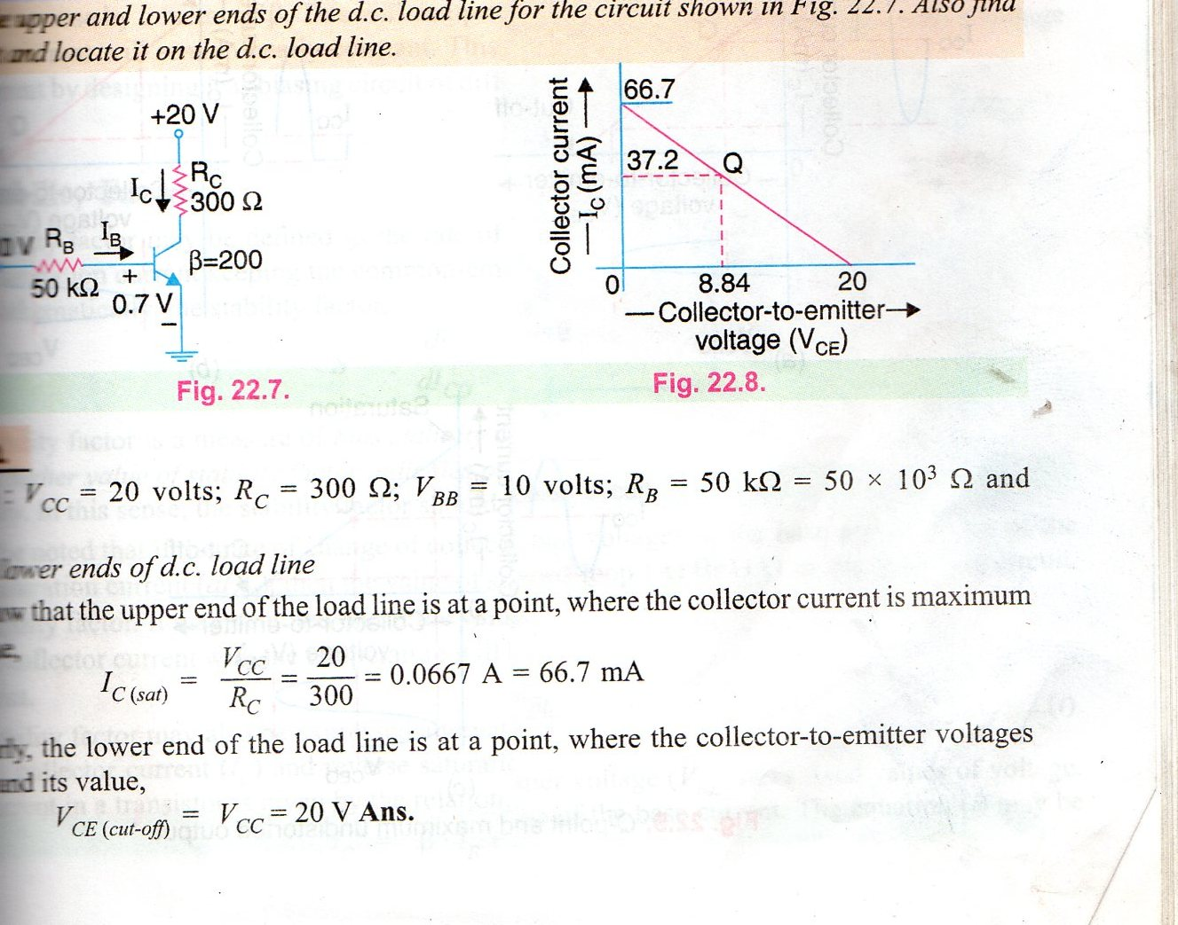

i.)the upper and lower ends of the dc load line
ii.)find Q-point
iii.locate Qpoint on the dc load line
iv.)Explain the simpler way of drawing dc load line
c. Briefly discuss with diagrams the following methods of fabricating BJT transistors

i). Diffused Technique (5marks)

ii. Epitaxial Technique (5marks)

QUESTION FOUR (20 MARKS)

a).Briefly discus the need of transistor biasing and state various types of transistor biasing circuits (5marks)

b). Define stability factor for BJTs. (2marks)

c). Transistors can be used as amplifiers. Justify this statement by discussing with aid of diagrams the three basic circuits for transistor amplifier (5marks)

d). Compare bipolar junction transistor (BJT) and Field Effect Transistor (FET.) ( 3marks)

e.) The transistor has I_{E} = 10 mA and α = 0.98. Find the value of base I_{B} and collector I_{C} currents. (2marks)
f. Draw the input and output characteristics of a transistor in CE configuration
and mark the cut-off, saturation and active regions. (3marks)

-END-

