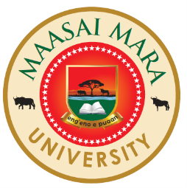
MAASAI MARA UNIVERSITY

REGULAR UNIVERSITY EXAMINATIONS 2017/2018 ACADEMIC YEAR
THIRD YEAR SECOND SEMESTER

SCHOOL OF ARTS & SOCIAL SCIENCES
BACHELOR OF EDUCATION (ARTS)

COURSE CODE: REL 324
COURSE TITLE: TRADITIONAL AFRICAN HEALING
AND SCIENCE

DATE: 24TH AUGUST 2018 TIME: 1430-1630HRS
INSTRUCTIONS TO CANDIDATES
Answer question ONE and any other TWO.

- a. Explain how Traditional African Communities conceptualize the relationship between Religion and Healing (10 Marks)

b. Assess the extent to which Traditional African healing is a “HOLISTIC DISCIPLINE”?
(20 Marks)

2 Discuss constraining challenges affecting the use of African Traditional Herbal Medicine in modern Africa. (20 Marks)

3 Discuss the Biblical views on the use of herbal medicine. (20 Marks)

4 Explain the major components of healing by an African specialist. (20 Marks)

5 Examine the causes, management and control of diseases in Traditional
African societies.
(20 Marks)
END//

