MAASAI MARA UNIVERSITY
REGULAR UNIVERSITY EXAMINATIONS
2017/2018 ACADEMIC YEAR
SECOND YEAR FIRST SEMESTER
SCHOOL OF ARTS & SOCIAL SCIENCES
BA LANGUAGES & COMMUNICATION STUDIES

COURSE CODE: LAC 2104
COURSE TITLE: LANGUAGE & ADVERTISING
DATE: 5TH DECEMBER, 2017 TIME:0830 – 1030HRS
INSTRUCTIONS TO CANDIDATES
Question ONE is compulsory
Answer any other TWO questions

QUESTION ONE
Observe the following advertisements and answer the questions that follow:
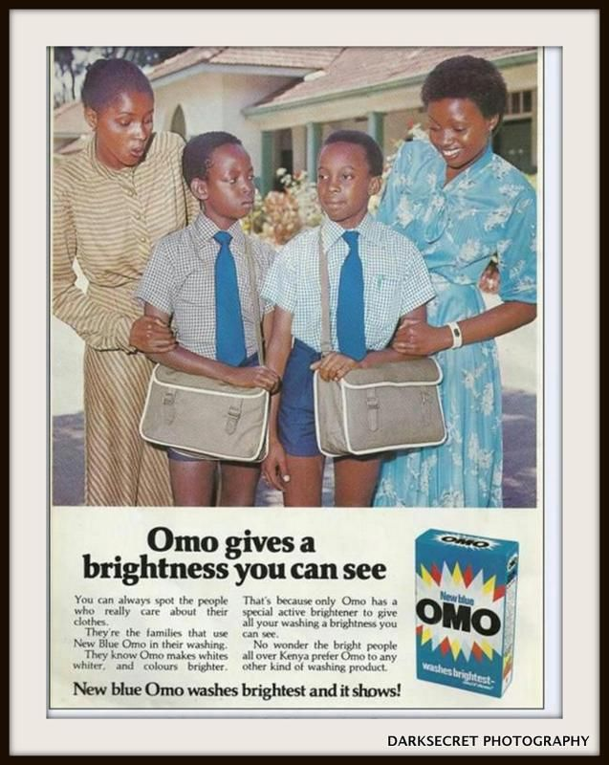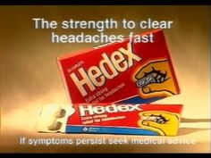
- Categorize the above advertisements with appropriate reasons.
[4 marks]
- Explain the functions of language in the advertisements. [3 marks]
- Explain the layout and structure of the above advertisements.
[6 marks]
- Perform a rhetorical analysis of the above advertisement using any two parameters of your choice. [6 marks]
- Undertake a media literacy analysis using any two parameters of your choice. [6 marks]
- Perform a linguistic analysis using any two parameters of your choice.
[6 marks]
QUESTION TWO
Using appropriate examples, discuss four types of advertisements and highlight strengths and weakness of each. [20 marks]

QUESTION THREE
You have been appointed as the Communication Manager of Maasai Mara University. The University management has requested you to prepare an advertisement campaign plan. Explain the key elements of your plan and mode of execution. [20 marks]

QUESTION FOUR
Your consultancy firm has been contracted by one of the presidential candidates on preparation of effective political advertisements. Discuss five techniques of advertising that would form the basis of your counsel.
[20 marks]
QUESTION FIVE
Using suitable illustrations, discuss four linguistic features used to analyze advertisements.
[20 marks]

///////////////////////END///////////////////////////////////

